Jennifer Stegina

20 September 2019

CIS 250

**Unit 4 Graded Exercise 1**

The following questions come from the “Check your understanding” examples of Chapter 13 in your textbook.

After you are finished, please submit a Microsoft Word file that contains your answers. In this case, since the assignments are “by hand,” you don’t have to run these in Oracle. Your document should be named **U4_GradedExercise1_Lastname.docx**.

(13-3) Question 1:

Do these joins by hand, without a computer. Join a row of Table 1 with a row of Table 2 if the first letters are the same. Show all the rows of both tables, even if they do not have a matching row in the other table. Create the result table and state if this is a one-to-one relationship in the mathematical sense or in the database design sense.

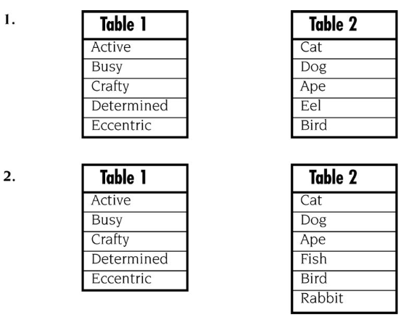

1. Table 1 Table 2

Active Ape

Busy Bird

Crafty Cat

Determined Dog

Eccentric Eel

This is a one-to-one relationship in the mathematical sense.

1. Table 1 Table 2

Active Ape

Busy Bird

Crafty Cat

Determined Dog

Eccentric Null

Null Fish

Null Rabbit

This is a one-to-one relationship in the database sense.

(13-4) Question 2:

Do this join by hand, without a computer. Join a row of Table 1 with a row of Table 2 if the first letters are the same. Create the result table and state if this is a many-to-one relationship.

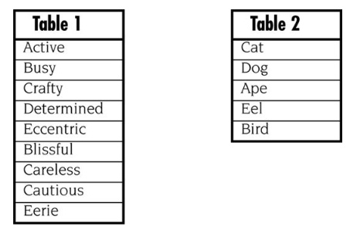

Table 1 Table 2

Active Ape

Busy Bird

Crafty Cat

Determined Dog

Eccentric Eel

Blissful Bird

Careless Cat

Cautious Cat

Eerie Eel

This is a many-to-one relationship.

(13-5) Question 3:

Do this join by hand, without a computer. Join a row of Table 1 with a row of Table 2 if the first letters are the same. Create the result table and state if this is a one-to-many relationship.

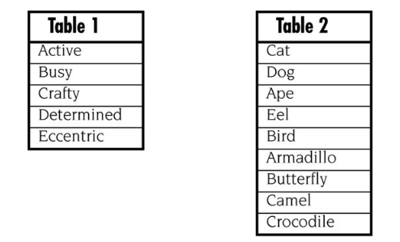

Table 1 Table 2

Active Ape

Active Armadillo

Busy Bird

Busy Butterfly

Crafty Cat

Crafty Camel

Crafty Crocodile

Determined Dog

Eccentric Eel

This is a one-to-many relationship.

(13-6) Question 4:

Do this join by hand, without a computer. Join a row of Table 1 with a row of Table 2 if the first letters are the same. Create the result table and state if this is a many-to-many relationship.

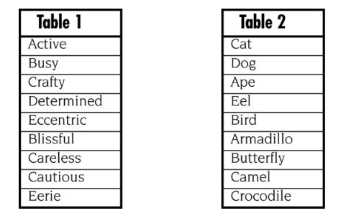

Table 1 Table 2

Active Ape

Active Armadillo

Busy Bird

Busy Butterfly

Crafty Cat

Crafty Camel

Crafty Crocodile

Determined Dog

Eccentric Eel

Blissful Bird

Blissful Butterfly

Careless Cat

Careless Camel

Careless Crocodile

Cautious Cat

Cautious Camel

Cautious Crocodile

Eerie Eel

This is a many-to-many relationship.

(13-8) Question 5:

Which rows from each table are unmatched and would be dropped from the inner join? Assume a row of Table 1 would be joined with a row of Table 2 if the first letters are the same.

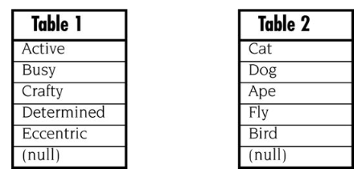

The following would be dropped:

Table 1 Table 2

Eccentric

Null

Fly

Null

(13-9) Question 6:

Write a *select* statement to create the inner join of these tables. Join a row of Table 1 with a row of Table 2 if the first letters are the same. Write the SQL in the recommended way, using variation 1.

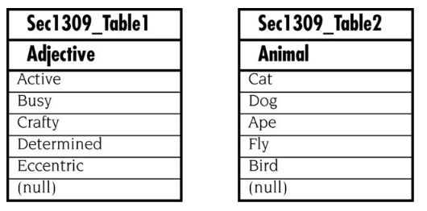

Select a.adjective, b.animal

From sec1309_table1 a, sec1309_table2 b

Where substr(adjective, 1, 1) = substr(animal, 1, 1)

Order by a.adjective;